Familiarity enhances coordination and efficiency in complex collective tasks

Marcelo Araya-Salas^{1,2}, Damien R. Farine^{3,4}, Holger Goerlitz⁵, Nazareth Rojas-Rojas⁶, Silvia Chaves-Ramírez⁷, Mariela Sánchez-Chavarría⁸, Gloriana Chaverri^{9,10}

Affiliations:
1 Centro de Investigación en Neurociencias, Universidad de Costa Rica,
San José, Costa Rica
2 Escuela de Biología, Universidad de Costa Rica, San José, Costa Rica
5 Max Planck Institute for Biological Intelligence, Seewiesen, Germay
9 Sede del Sur, Universidad de Costa Rica, Golfito, Costa Rica
10 Smithsonian Tropical Research Institute, Balboa, Ancón, Republica de Panamá

Abstract
Familiarity among group members is thought to enhance the performance of animal groups facing complex ecological challenges. In humans, stable group membership—often termed “team familiarity”—improves coordination and efficiency. Yet, direct evidence from wild collectives is limited. To test whether this principle extends to other species, we examined natural groups of Spix’s disc-winged bats (Thyroptera tricolor) and experimentally assembled unfamiliar groups. Using three-dimensional flight reconstructions and roost-entry trials, we found that familiar groups maintained closer spatial cohesion, entered roosts in tighter synchrony, and collectively produced more acoustic signals while still minimizing signal overlap. These findings show that familiarity facilitates communication and coordination, extending the concept of team familiarity beyond humans and highlighting a general principle of collective success in animal societies.

Animals can express remarkable collective behaviours, such as ants linking their bodies to form living bridges (1), honeybee swarms reaching consensus on the location of a new nest site (2) or predators coordinating group hunts (3). Although these feats may seem complex, they often emerge from simple rules. For example, local interactions among individuals can allow groups to track complex environmental gradients (4) while effectively detecting and avoiding predators (5, 6). One feature of these simple rule-based collective actions is that they can operate despite the individual constituents being largely anonymous, as is widely observed in schools of fish (7) and flocks of birds (8). Yet, human groups with stable membership consistently outperform those with fluctuating membership (9–11), especially when decisions require greater cooperation and efficient communication (12, 13). This phenomenon has been formalized as the concept of “team familiarity”, which highlights how repeated experiences among the same individuals improves their coordination and performance (14, 15). An important question is therefore whether familiarity among group members also enhances the ability of other animal collectives to solve challenges that demand particularly intricate coordination and communication.
We experimentally tested whether familiarity increases group performance during collective tasks by non-human animals. Lab experiments using fish have shown that familiarity can increase coordination in schools (16, 17) and facilitate transmission of information (18, 19). However, testing this link in natural groups is difficult because high familiarity is intrinsically linked with strong spatial cohesion and living in stable groups, such as groups of primates (20) and birds (21) where individuals live and move together. This limits our ability to compare performance of collectives at solving ecologically relevant challenges in both familiar and unfamiliar settings. We overcome this challenge by bringing wild-caught groups of Spix’s disc-winged bat (Thyroptera tricolor), a Neotropical species characterized by high social stability, temporarily (< 6 h) into captivity. This species forms long-term stable groups of about five individuals (range 2–9) that sleep inside developing tubular leaves of plants in the order Zingiberales, such as heliconias and bananas (22–24). Because these leaves unfurl after approximately one day, groups must repeatedly find new sleeping sites (25). Group members also have to enter the leaf in rapid succession to reduce both individual predation risk and overall group detectability (26, 27). This spatial and temporal ecological challenge is readily replicated in laboratory conditions.

We used videos from four cameras to reconstruct the 3-dimensional trajectories of individuals flying alone, in natural (high familiarity) groups and in artificial groups (novel combinations of individuals from several natural groups) within a large flight cage (9 x 4 x 3 m; Figure 1a-b). If familiarity plays an important role in collective behaviours, we expected that the high familiarity groups would show greater spatial cohesion than the artificial groups. Annotating 5 s segments where the trajectories of all individuals were visible confirmed this prediction, with the data revealing that bats in natural groups flew significantly closer to one-another than bats in artificial groups (Figure 2). Artificial groups did not differ from random expectation (‘simulated groups’ where the flight trajectories of individuals from different trials were combined; Figure 1c and 2), confirming that familiarity facilitates greater coordination.
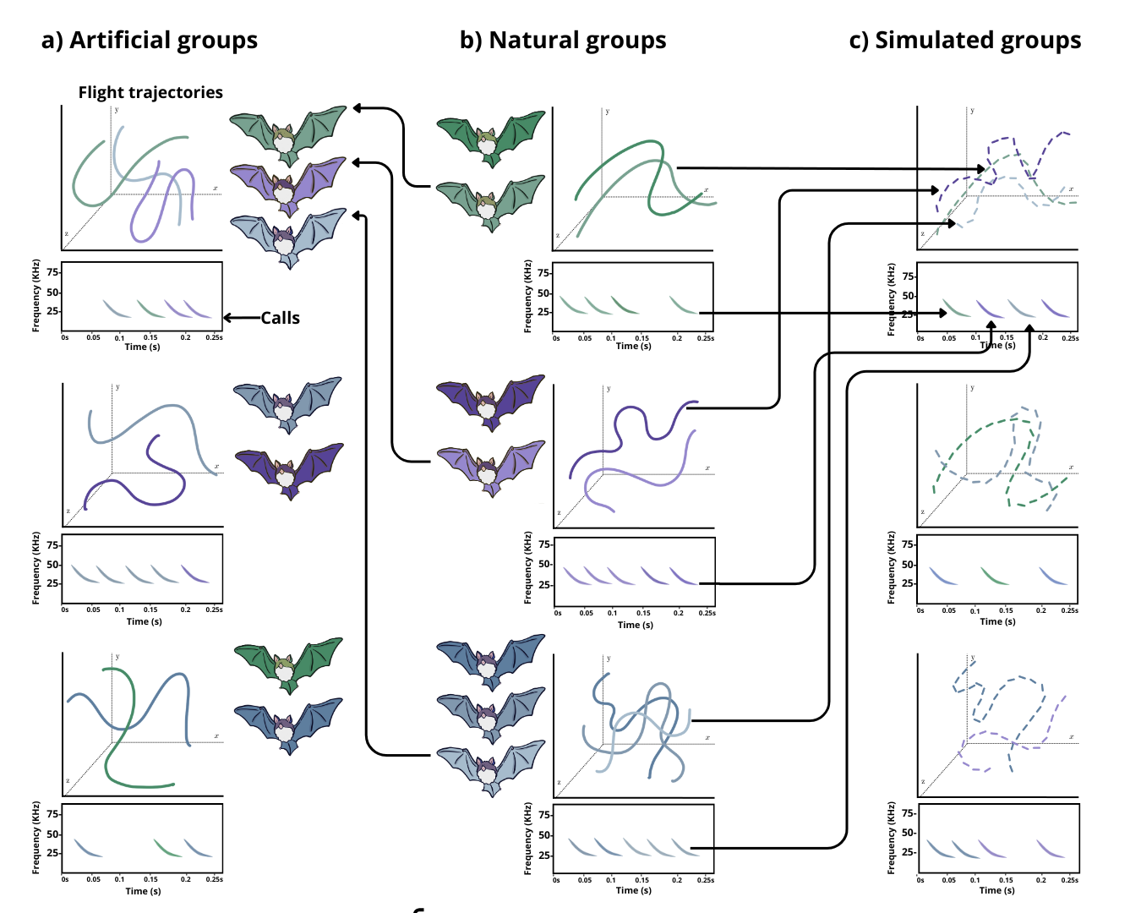

Fig. 1. Scheme of the experimental design to assess group flight and calling coordination. Hypothetical artificial (a) and natural (b) groups are shown next to a schematic 3D flight trajectory and a spectrogram of the vocal activity with multiple inquiry calls. Natural group membership is depicted by color tonality and the trajectories and calls from a given individual match its color. Artificial groups were composed by individuals from different natural groups (depicted by arrows from natural to artificial group bats) while simulated groups (c) were digitally created by combining flight trajectories and calling activities from those registered in natural groups (illustrated by the arrows from the trajectories and calls from natural to simulated groups).

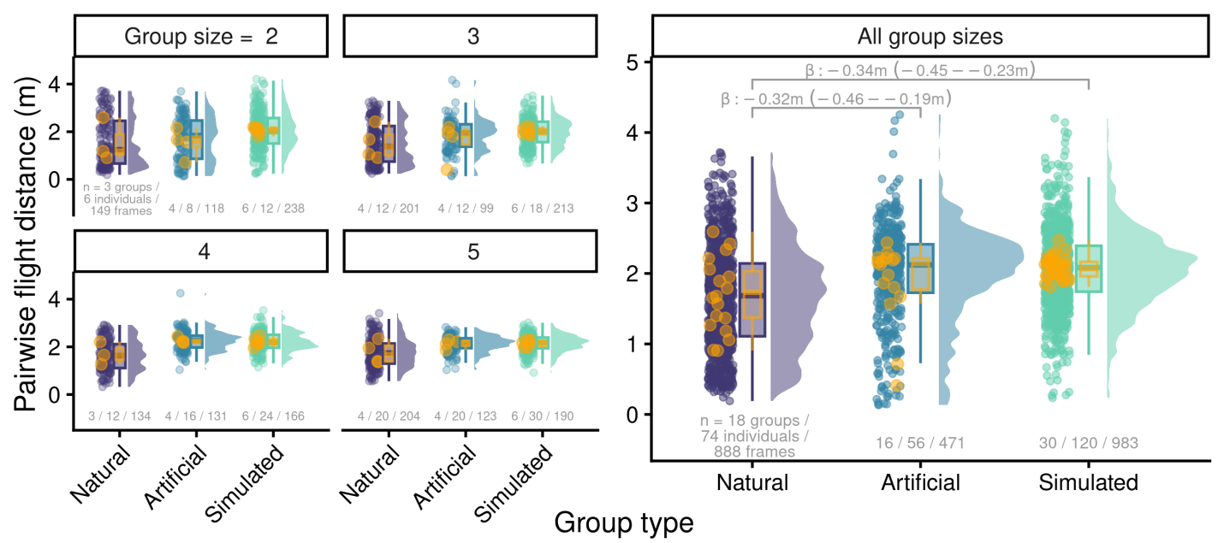

Fig. 2. Raincloud plot showing the jittered pairwise distance among individuals per frame and the associated boxplots (median, interquartile range and overall range) and half violin plots, by group flight type (horizontal axis) and group size (panels). For simplicity, data for groups of six individuals is not shown. The right panel shows aggregated data for all group sizes. Yellow points show the mean pairwise distance per group with their distribution represented by overlaid yellow boxplots. Brackets above boxplots in the right panel indicate statistically detectable differences with effect size and 95% uncertainty intervals (in m). Sample sizes for groups and individuals are shown underneath boxplots.

Synchronising actions plays an important role in reducing predation risk across a range of contexts. For example, breeding groups of birds often synchronise their provisioning by approaching the nest together to reduce nest visitation rates and thus avoiding detection of nest location by predators (28, 29). Groups of Spix’s disc-winged bat face this same challenge on a daily basis, as they require first finding a suitable new leaf in which to roost and then coordinating their entry to reduce the chances of detection by a range of avian and mammalian predators. Placing a furled leaf of Heliconia sp. or Calathea lutea at random positions (Figure 3) within the flight cage and measuring the time from release into the flight cage until entering the leaf confirmed that natural (familiar) groups were substantially more synchronised — i.e., had shorter intervals between bats entering the leaf — than artificial (unfamiliar) groups (Figure 4). We also created simulated groups by combining the entry times of solitary bats finding and entering the leaf (Figure 3c) to gain an insight into the size of the effect of familiarity relative to the benefits from grouping alone. We found that familiarity reduced the time between successive entries to approximately one quarter compared to these simulated groups (12.4 s vs 54.3 s, Figure 4). This confirms that coordination in this collective task is substantially greater when bats are familiar rather than unfamiliar.

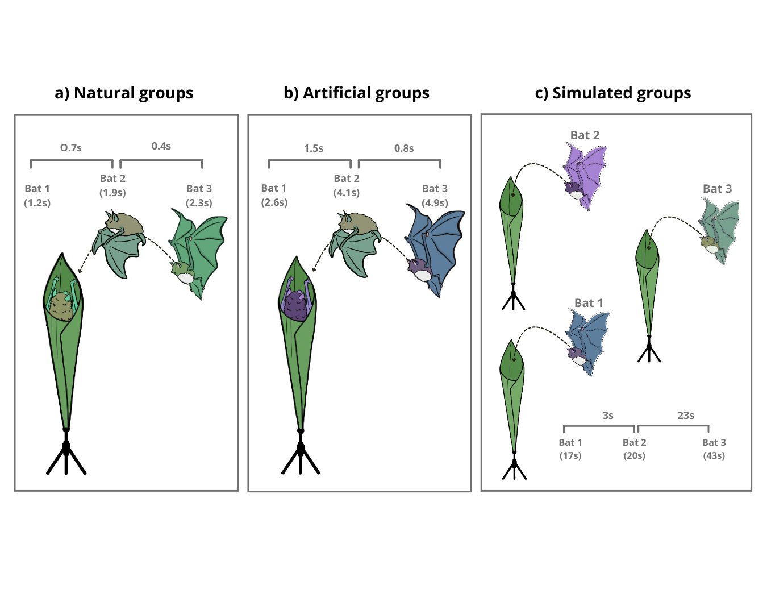
Fig. 3. Scheme of the experimental design to assess roost entry synchrony. Synchronization was quantified as the time lapse between successive individuals when entering the roost. Artificial groups (b) were composed by individuals from different natural groups (a) while simulated groups (c) were digitally created by combining entry times from single individual trials.

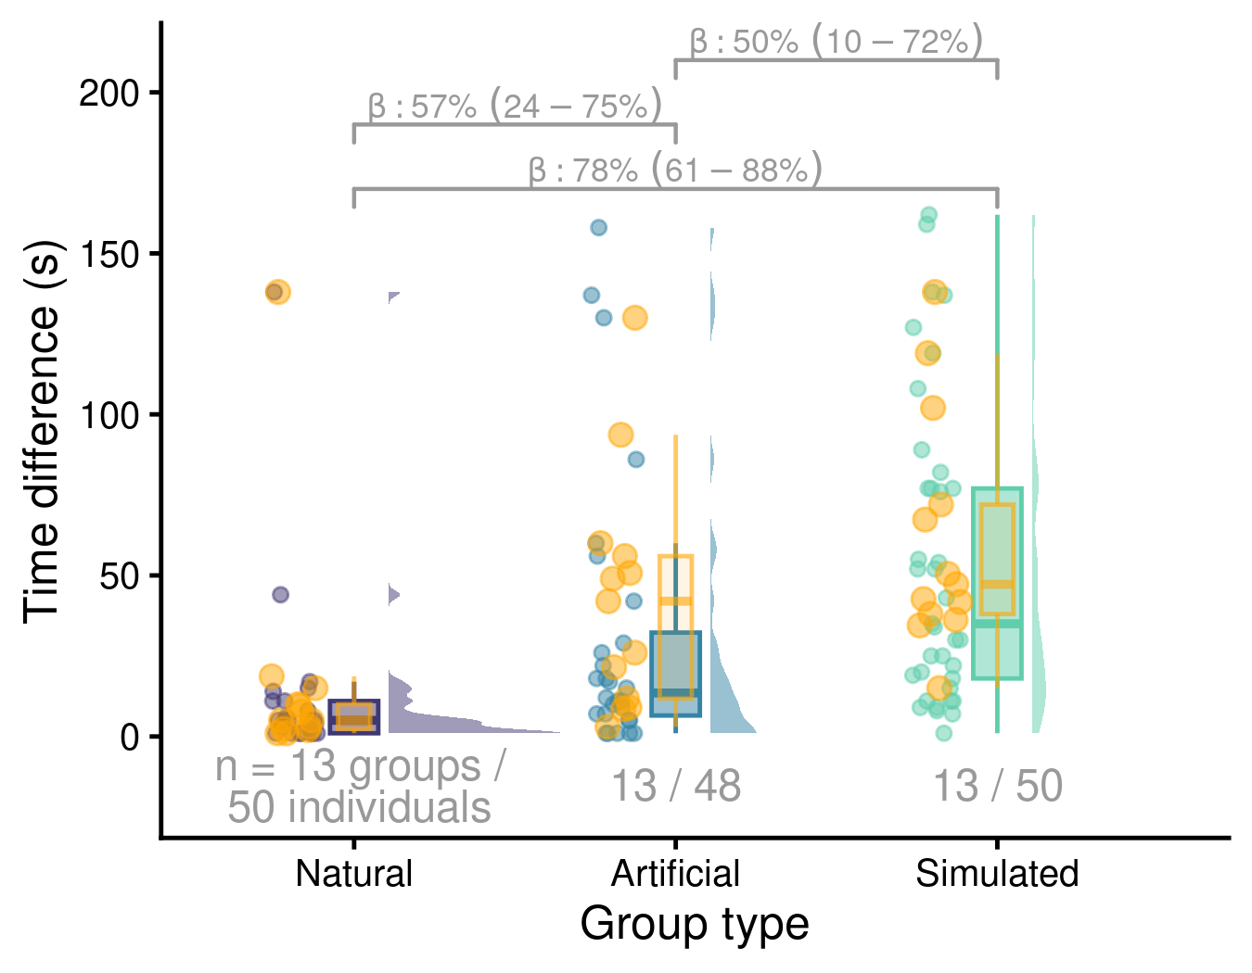
Fig. 4. Raincloud plots showing the time difference (s) between successive individuals entering a roost. Jittered points represent individual-level observations, with associated boxplots (median, interquartile range, and overall range) and half-violin plots shown for each group flight type. Yellow points indicate group-level mean time differences, with their distribution summarized by overlaid yellow boxplots. Brackets above boxplots denote statistically detectable differences between group types, with effect sizes and 95% uncertainty intervals expressed as percentage reductions in the time between successive entries. Sample sizes for groups and individuals are shown below each boxplot.

Maintaining close spatial cohesion plays an important role in allowing bats to remain together while navigating the dense rainforest and finding roosts. Such precise coordination—in both space and time—relies on effective communication. Communication plays a central role in the performance of human teams (13, 30, 31) and has been linked to increased familiarity (13, 32). However, complex environments—such as rainforests—introduce barriers to effective communication. Fish schools that experience reduced access to visual information, such as in turbid waters, increases cohesion (33) but make slower and less accurate decisions (34), while ants deposit (and rely more on) pheromones in low-light conditions (35, 36). Birds, which have access to both visual and vocal communication systems, are more likely to switch to making acoustic alarm calls when in longer than when in shorter grass (37). Spix’s disc-winged bats have limited visual information both due to vegetation density and due to flying in the dark, but employ a dual call system for coordinating movements and locating roosts. Flying individuals constantly emit ultrasonic inquiry calls while searching for a roost, which are typically answered by response calls from individuals already inside the roost (38). However, a challenge for acoustic communication is it can easily suffer from information masking or signal jamming (39). This ‘cocktail party effect’ arises when many individuals are trying to vocalise simultaneously.

Mitigating the cocktail party effect requires coordinating the delivery of inquiry calls to minimize temporal overlap while maintaining a constant vocal output to maintain sufficient information transmission. We recorded calls of solitary bats, natural (familiar) groups and artificial (unfamiliar) groups, applying individual call identification models in group settings to obtain data on call rates. We found distinct differences in how bats called in familiar versus unfamiliar groups. Both natural and artificial groups experienced less call overlap than expected by chance (simulated groups created by combining solitary flights; Figure 5a), indicating active avoidance of signal jamming at the group level. This seems to be achieved by adjusting calling rates at the individual level, as call rates per bat during group flights were lower than those in solo flights (Figure 5b). However, group-level call rates in natural groups were significantly higher than in artificial groups (and similar to those of solitary individuals, Fig 5c), suggesting that familiar groups can produce a collective signal that maintains a higher level of acoustic information than unfamiliar groups.

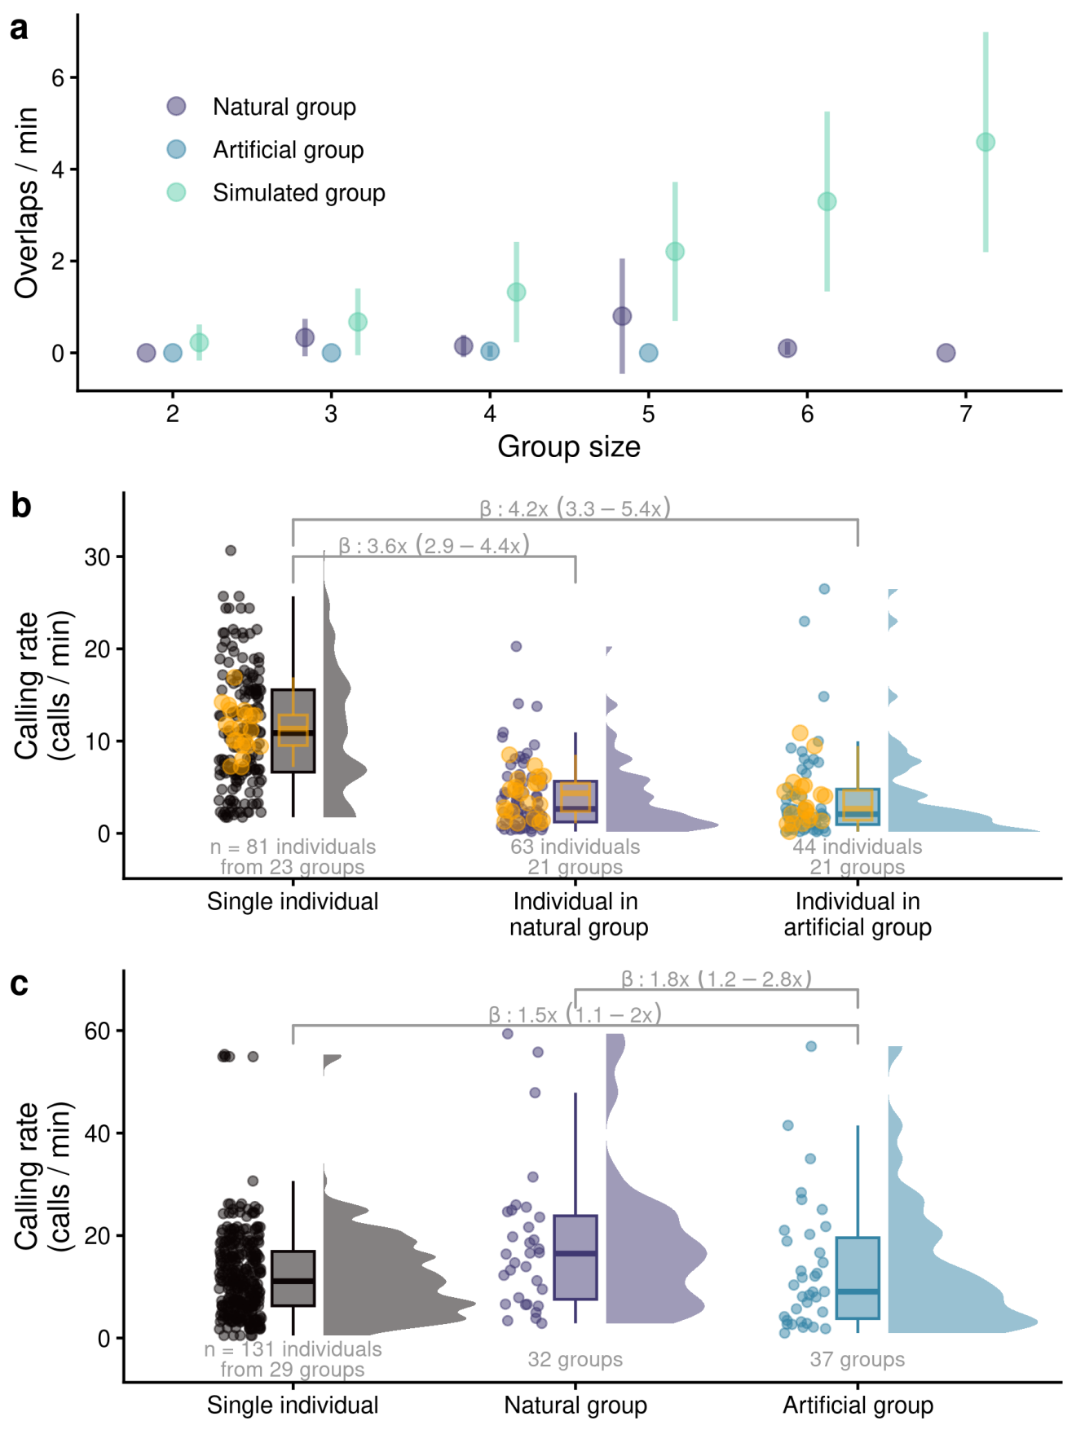
Fig. 5. Vocal coordination and familiarity. a) Individual inquiry call rate for individuals in solo flights vs call rates of individuals in natural and artificial groups. B) Individual inquiry call rate for single individuals in solo flights vs group level call rates from natural and artificial groups. Data in a) and b) is shown as raincloud plots of raw data points, boxplots (median, interquartile range and overall range) and half violin plots. Brackets above boxplots indicate statistically detectable differences with effect size and 95% uncertainty intervals as multiplicative differences in calling rate. Sample sizes for groups and individuals are shown underneath boxplots. Yellow points show the mean call rate per group with their distribution represented by overlaid yellow boxplots. a) Average number of inquiry call overlaps in group flights. Simulated values were obtained from 1000 iterations of a custom routine that combined single individual calling data from solo flights.

The distinct differences in how natural and artificial groups performed at solving an ecologically relevant task highlights the important contribution of familiarity to collective behaviour by non-human animals. The benefits of familiarity appear to arise specifically through more effective communication, as previously found in human groups (13, 32). In addition, unfamiliarity itself can impose costs: groups of strangers often function less efficiently because individuals must devote attention to evaluating and predicting the behaviour of unfamiliar partners, a cognitively demanding task that can detract from coordination (40, 41). The importance of familiarity and its role in facilitating communication and coordination in various collective tasks that we have uncovered in this study is likely to have widespread importance among social animals. Maintaining cohesion, precisely coordinating actions, and making synchronous collective movements, underpins many ecological processes ranging from reproductive ecology (40, 42–45) through to migration (46–48) that are frequently undertaken in familiar groups. Our findings therefore extend the concept of “team familiarity” beyond humans, showing it to be a general principle of collective life. By demonstrating that even small bat societies rely on familiarity to succeed in critical ecological challenges, this work highlights a common thread linking human collaboration with the collective strategies that shape animal societies across taxa.

References

1. C. R. Reid et al., Proc. Natl. Acad. Sci. U.S.A. 112, 15113–15118 (2015).
2. T. D. Seeley, Behav Ecol Sociobiol. 53, 417–424 (2003).
3. M. J. Hansen, P. Domenici, P. Bartashevich, A. Burns, J. Krause, Biological Reviews. 98, 1687–1711 (2023).
4. A. Berdahl, C. J. Torney, C. C. Ioannou, J. J. Faria, I. D. Couzin, Science. 339, 574–576 (2013).
5. R. E. Kenward, The Journal of Animal Ecology. 47, 449 (1978).
6. W. Cresswell, Animal Behaviour. 47, 433–442 (1994).
7. J. E. Herbert-Read et al., Proc. Natl. Acad. Sci. U.S.A. 108, 18726–18731 (2011).
8. M. Ballerini et al., Animal Behaviour. 76, 201–215 (2008).
9. F. Montanari, G. Silvestri, E. Gallo, Journal of Sport Management. 22, 701–716 (2008).
10. B. Muskat, A. Anand, C. Contessotto, A. H. T. Tan, G. Park, Human Resource Management Review. 32, 100892 (2022).
11. K. Joshi, J. Hernandez, J. Martinez, K. AbdelFattah, A. K. Gardner, The American Journal of Surgery. 215, 243–249 (2018).
12. D. H. Gruenfeld, E. A. Mannix, K. Y. Williams, M. A. Neale, Organizational Behavior and Human Decision Processes. 67, 1–15 (1996).
13. N. Oesch, R. I. M. Dunbar, Ethology. 124, 483–495 (2018).
14. R. S. Huckman, Harvard Business Review. 91, 27–29 (2013).
15. R. S. Huckman, B. R. Staats, D. M. Upton, Management Science. 55, 85–100 (2009).
16. S. Davis, R. Lukeman, T. M. Schaerf, A. J. W. Ward, R. Soc. open sci. 4, 170312 (2017).
17. L. E. Nadler, M. I. McCormick, J. L. Johansen, P. Domenici, Commun Biol. 4, 897 (2021).
18. W. Swaney, J. Kendal, H. Capon, C. Brown, K. N. Laland, Animal Behaviour. 62, 591–598 (2001).
19. N. Atton, B. J. Galef, W. Hoppitt, M. M. Webster, K. N. Laland, Proc. R. Soc. B. 281, 20140579 (2014).
20. A. Strandburg-Peshkin, D. R. Farine, I. D. Couzin, M. C. Crofoot, Science. 348, 1358–1361 (2015).
21. D. Papageorgiou, B. Nyaguthii, D. R. Farine, Commun Biol. 7, 95 (2024).
22. G. Chaverri, Behavioral Ecology and Sociobiology. 64, 1619–1630 (2010).
23. M. J. Vonhof, H. Whitehead, M. B. Fenton, Animal Behaviour. 68, 507–521 (2004).
24. J. S. Findley, D. E. Wilson, Journal of Mammalogy. 55, 562–571 (1974).
25. M. J. Vonhof, M. B. Fenton, Journal of Tropical Ecology. 20, 291–305 (2004).
26. L. J. Morrell, R. James, Behavioral Ecology. 19, 193–201 (2008).
27. J. Krause, G. D. Ruxton, Living in groups (Oxford University Press, New York, 2002).
28. N. J. Raihani, M. J. Nelson‐Flower, K. Moyes, L. E. Browning, A. R. Ridley, Journal of Animal Ecology. 79, 44–52 (2010).
29. K. Bebbington, B. J. Hatchwell, BEHECO. 27, 652–659 (2016).
30. S. L. Marlow, C. N. Lacerenza, J. Paoletti, C. S. Burke, E. Salas, Organizational Behavior and Human Decision Processes. 144, 145–170 (2018).
31. J. R. Mesmer-Magnus, L. A. DeChurch, Journal of Applied Psychology. 94, 535–546 (2009).
32. A. J. King et al., Biol. Lett. 7, 237–240 (2011).
33. H. E. A. MacGregor, C. C. Ioannou, Ecology and Evolution. 13, e10708 (2023).
34. A. C. Chamberlain, C. C. Ioannou, Animal Behaviour. 156, 129–138 (2019).
35. S. Jones et al., Animal Behaviour. 156, 87–95 (2019).
36. J. R. Attwell, thesis, University of Bristol, Bristol, England (2023).
37. C. L. Devereux, E. Fernàndez‐Juricic, J. R. Krebs, M. J. Whittingham, Ibis. 150, 191–198 (2008).
38. G. Chaverri, E. H. Gillam, M. J. Vonhof, Biology Letters. 6, 441–444 (2010).
39. C.-C. Liao, R. D. Magrath, M. B. Manser, D. R. Farine, Phil. Trans. R. Soc. B. 379, 20230184 (2024).
40. M. A. Strodl, P. Schausberger, Oikos. 122, 1217–1226 (2013).
41. S. W. Griffiths, S. Brockmark, J. Höjesjö, J. I. Johnsson, Proc. R. Soc. Lond. B. 271, 695–699 (2004).
42. M. M. Mariette, S. C. Griffith, Journal of Avian Biology. 43, 131–140 (2012).
43. C. Doutrelant, R. Covas, Animal Behaviour. 74, 739–747 (2007).
44. K. E. Lucia, B. Keane, Behav Ecol Sociobiol. 66, 13–27 (2012).
45. A. Culina, J. A. Firth, C. A. Hinde, Proc. R. Soc. B. 287, 20201554 (2020).
46. P. Byholm, M. Beal, N. Isaksson, U. Lötberg, S. Åkesson, Nat Commun. 13, 1566 (2022).
47. R. Chetverikova, O. Babushkina, S. Galkina, V. Shokhrin, J. Bojarinova, Behav Ecol Sociobiol. 71, 40 (2017).
48. A. Kölzsch et al., Journal of Avian Biology, in press, doi:10.1111/jav.02392.

